DAYANANDA SAGAR COLLEGE OF ARTS, SCIENCE AND COMMERCE,

DEPARTMENT OF COMPUTER APPLICATIONS,
BANGALORE -111.

Master of Computer Applications
MCA 2023-25


A Project Report
On
BIGGR-DASHBOARD

Submitted by

NAGARAJ K
PO3CJ23S126062

In partial fulfilment of the requirements for the award of the degree of Master of Computer Applications, Bangalore University

Under the guidance of

Internal Guide External Guide
Prof. Kiran CK Mr. Rahul Roonwal
(Associate Professor, DSCASC) Compliance Head
B C Global Solutions LLP
DAYANANDA SAGAR COLLEGE OF ARTS,
SCIENCE AND COMMERCE,

DEPARTMENT OF COMPUTER APPLICATIONS,
BANGALORE -111.

Master of Computer Applications
MCA 2023 – 2025


CERTIFICATE

This is to certify that NAGARAJ K (PO3CJ23S126062) of IV semester MCA has satisfactorily completed the project work during July 2025 – November 2025, entitled “BIGGR-DASHBOARD” in partial fulfilment of the requirements for the award of the degree of Master of Computer Applications under Bangalore University.

Prof. Kiran C K Prof. Dr. Kumudavalli
Project Guide Deputy Director
DSCASC DSCASC

Date: Signature of the Examiners:
1.
2.

INDEX
SL NO | CONTENTS | PAGE NO
1 | Abstract
2 | Acknowledge
3 | Certification
4 | Student Declaration
5 | Introduction
6 | Organization Profile
7 | Scope of the system.  7.1 System Overview  7.2 Existing System  7.3 Problems in existing system  7.4 Benefits of Proposed system  7.5 Features of Proposed System
8 | System Analysis  8.1 Hardware & Software Requirements  8.2 Preliminary Investigation  8.3 Feasibility Study  8.4 Data Flow Diagram
9 | Planning.  9.1 Resource Estimation  9.1.1 Human Resources  9.1.2 Technical Resources  9.2 Cost Estimation  9.2.1 Development Cost  9.2.2 API & Integration Cost  9.2.3 Infrastructure Cost  9.2.4 Maintenance Cost  9.3Software Engineering Paradigm applied  9.4 Scheduling  9.4.1 PERT Chart  9.4.2 Gantt Chart  9.5 System Requirements Specifications (SRS)  9.5.1 Functional Requirements  9.5.2 Non-Functional Requirements
10 | System Design.  10.1 Input Design  10.1.1 UML Diagrams  10.2 Output Design  10.3 Database Design  10.4 E-R Diagram  10.5 Modularization Details
11 | Implementation & Coding Guidelines  11.1 Pseudo Code of the Project  11.2 Coding Standards  11.3 Validation Checks
12 | System Testing  12.1 Testing Strategies  12.2 Test Plan  12.3 Test Cases  12.3.1 Test Cases for Admin  12.3.2 Test Cases for Candidate
13 | System Implementation  13.1 Implementation Strategies  13.2 Post Implementation
14 | System Security measures
15 | Screen Shots and Reports
16 | Scope for Improvement
17 | Tools Description
18 | Timing Diagram
19 | Conclusion
20 | Bibliography

ABSTRACT

Biggr is a next-generation e-commerce grocery delivery mobile application developed using the MERN stack (MongoDB, Express.js, React Native, and Node.js). The system is designed to simplify and digitize grocery shopping by offering users a seamless mobile experience to browse, purchase, and receive daily essentials from nearby stores — all within minutes. Built on a React Native front-end framework, Biggr ensures a fast, responsive, and cross-platform experience across both Android and iOS devices. The backend, powered by Node.js and Express.js, handles server-side logic, user authentication, and API communication efficiently, while MongoDB serves as the database for storing dynamic product catalogs, orders, and customer details with high scalability.

Biggr integrates essential features such as real-time inventory updates, order tracking, secure digital payments, and delivery status notifications, providing a complete end-to-end shopping solution. It also includes an admin dashboard for managing products, users, and delivery operations, ensuring operational transparency and efficiency. The system leverages RESTful APIs for smooth data exchange and implements JWT-based authentication for enhanced user security.

This project was developed using the Agile methodology, enabling continuous integration, testing, and iterative improvements. From a user perspective, Biggr delivers convenience and speed, while from a business stand point, it enables local vendors to reach a wider digital audience without heavy infrastructure investment.

The Biggr mobile application demonstrates how the MERN framework can be effectively utilized to develop a scalable, modular, and performance-driven platform that aligns with the growing demand for digital grocery delivery in urban India. Through its blend of technology, user-centric design, and operational reliability, Biggr showcases how modern web and mobile technologies can transform the retail grocery ecosystem into a smarter, faster, and more connected experience for both consumers and sellers.
ACKNOWLEDGEMENT

I sincerely thank all those who contributed to the successful completion of our project.
First and foremost, I extend our sincere thank to the college management for providing us with an excellent academic environment and the necessary resources to pursue our project work.
I am profoundly grateful to our respected Principal, Dr. Balu L, for his visionary leadership and continuous motivation, which inspired us to strive for excellence. Our heartfelt thanks also go to our Vice Principal, Prof. Hemanth Uppalla, for this constant support and encouragement throughout our academic journey.
I owe a special debt of gratitude to our Head of the Department and Deputy Director, Dr. Kumudavalli, for her invaluable guidance, insightful suggestions, and relentless efforts in shaping our project. Her expertise and encouragement have been instrumental in our learning process.
Lastly, I would like to extend our warmest thanks to our Prof. Kiran C K for their patient mentorship, constructive feedback, and unwavering support at every stage of this project.

THANK YOU,
NAGARAJ K(P03CJ23S126062)

CERTIFICATE

STUDENT DECLARATION
I hereby declare that i have carried out the entire work embodied in this project report at the Department of Computer Applications, Dayanananda Sagar College of Arts, Science and Commerce, Bangalore-111 Under the supervision of Prof. Kiran C K This report has not been submitted in part or full to award any diploma or degree in this or any other college or university.

NAGARAJ K - P03CJ23S126086

INTRODUCTION
In today’s fast-paced digital era, convenience and speed have become essential aspects of daily life. The exponential growth of e-commerce and mobile technology has transformed the way consumers purchase goods and services. Among these, the grocery sector has witnessed significant innovation with the rise of online grocery delivery platforms. Biggr, a MERN-based (MongoDB, Express.js, React Native, Node.js) mobile application, is designed to revolutionize grocery shopping by providing users with a fast, efficient, and reliable platform to order their daily essentials online and have them delivered directly to their doorstep.

The Biggr application bridges the gap between local grocery stores and end consumers by offering a user-friendly mobile interface, real-time inventory updates, and secure digital payment options. Users can conveniently browse through categorized product listings, compare prices, and place instant orders. Meanwhile, administrators and delivery agents can manage orders, inventory, and logistics through an integrated dashboard, ensuring transparency and operational control.

The project aims to overcome common issues associated with traditional grocery shopping—such as long queues, limited stock, and time constraints—by providing an automated, technology-driven solution. Biggr enhances the user experience by incorporating features like real-time delivery tracking, order notifications, and personalized recommendations powered by data analytics.

Technically, Biggr leverages React Native for building a cross-platform mobile interface, Node.js and Express.js for backend API handling, and MongoDB for scalable, cloud-based data management. The use of the MERN stack ensures high performance, flexibility, and ease of maintenance.
Overall, Biggr represents a blend of innovation and practicality—empowering consumers with a modern, digital grocery experience while enabling small retailers to expand their market reach.

Objective:

- To develop a user-friendly grocery delivery app that allows customers to browse, select, and purchase groceries conveniently through their mobile devices.
- To implement real-time order tracking and status updates, enabling users to monitor their delivery progress from placement to doorstep delivery.
- To provide a digital platform for local vendors and retailers to list their products, manage inventory, and expand their customer reach efficiently.
- To integrate secure online payment systems ensuring safe and reliable transactions through trusted gateways and encryption methods.
- To design a scalable backend architecture using Node.js and MongoDB for efficient handling of user data, product catalogs, and orders.
- To create a responsive cross-platform mobile interface using React Native that functions seamlessly on both Android and iOS devices.
- To reduce manual dependency and operational errors through automation in order processing, billing, and delivery coordination.
- To enhance the overall customer experience by providing features like personalized recommendations, product search filters, and quick reordering.
- To ensure system security and data privacy through authentication, role-based access control, and encrypted storage.
- To build a sustainable and future-ready delivery ecosystem that can integrate AI-based demand forecasting, route optimization, and loyalty programs in later versions.

ORGANIZATION PROFILE
BetterCompliance(BCGlobalSolutionsLLP)
Better Compliance is a recently established limited liability partnership, incorporated on 21st September 2024 and registered under the Registrar of Companies, Bangalore. Operating under the brand name Better Compliance, the firm is headquartered at Chetana Towers, Infantry Road Cross, MG Road, Bangalore, Karnataka. With designated partners Surendar Kumar and Neethu Kumari, the LLP has been set up with a modest contribution of ₹10,000, reflecting its early-stage status. The company positions itself as a niche service provider catering to Global Capability Centers (GCCs) in India, offering comprehensive solutions across tax, regulatory compliance, HR and talent management, workspace strategy, legal entity setup, and financial operations. Its services include corporate tax compliance, international taxation and transfer pricing, workforce recruitment and compensation structuring, workspace and IT infrastructure advisory, and end-to-end compliance management. Guided by its mission to empower growth, enhance compliance, and optimize efficiency, Better Compliance aims to help organizations seamlessly integrate into the Indian business ecosystem while mitigating risks and ensuring long-term operational scalability. Though currently a small team, the LLP is focused on building expertise in compliance and regulatory solutions, making it a growing player in the professional services space.

SCOPE OF THE SYSTEM

4.1 System Overview
Customer Module: Allows users to register, browse products, add items to cart, checkout, and track delivery in real time. Facilitates order history viewing, repeat orders, and feedback submissions. Vendor/Store Module: Enables vendors to add, update, or remove products and manage pricing and stock levels. Provides analytics on sales, revenue, and customer trends. Admin Module: Central control system to manage users, vendors, products, orders, and delivery logistics. Generates analytical reports for performance evaluation and system monitoring. Delivery Partner Module: Displays assigned delivery tasks and pickup/drop locations. Tracks delivery progress and updates order status in real-time. Payment Gateway Integration: Supports multiple payment methods such as UPI, debit/credit cards, and wallets. Ensures encrypted transactions and secure payment confirmation. Notification & Communication System: Provides push notifications, SMS, and email alerts for order confirmations, updates, and promotions. Maintains communication between customer, vendor, and delivery agent for transparency.
4.2 Existing System
The existing grocery shopping system primarily relies on traditional, manual methods where customers physically visit stores, select products, wait in billing queues, and make payments either in cash or through limited digital options. This process is time-consuming, labor-intensive, and inconvenient, especially for working individuals with busy schedules. While a few online grocery platforms exist, most of them are either limited to specific regions or lack complete integration of features like real-time inventory updates, secure payments, and efficient delivery tracking. Local grocery vendors, who form the backbone of the retail ecosystem, often lack access to digital infrastructure, making it difficult for them to reach a larger customer base. Additionally, many stores still manage their inventory and billing manually, which leads to errors, delays, and poor data management. Existing systems also fail to provide personalized recommendations or loyalty-based features, resulting in lower customer retention and engagement. The absence of a unified platform connecting customers, vendors, and delivery agents causes communication gaps and operational inefficiencies. Moreover, these systems are not scalable and struggle to handle large volumes of orders during peak times. Overall, the current grocery retail model lacks automation, transparency, and convenience — highlighting the need for a comprehensive, technology-driven solution like Biggr, which aims to integrate all these functions into a single, efficient, and user-friendly mobile application.
4.3 Problems in Existing System
Time-Consuming and Inconvenient Process: Customers need to visit physical stores, search for products manually, and wait in long queues, making grocery shopping inefficient and tiring. Lack of Real-Time Inventory and Order Tracking: Traditional systems do not display live stock updates or provide order tracking, often resulting in item unavailability and uncertainty about delivery status. Manual Operations and Poor Coordination: Most stores rely on manual billing, inventory handling, and delivery management, leading to human errors, delays, and miscommunication between vendors and customers. Limited Payment and Security Options: Existing systems support only basic or cash-based payments and lack secure, encrypted gateways for online transactions. Low Scalability and Customer Engagement: Current systems cannot handle high order volumes and fail to provide personalized experiences such as recommendations, offers, or loyalty programs, resulting in low retention.
4.4 Benefits of Proposed System
- Real-Time and Automated Operations: Biggr automates processes like order placement, billing, and delivery tracking, providing users with live updates on product availability and delivery status while reducing manual errors.
- Convenience and Accessibility: Customers can shop for groceries anytime, anywhere through a user-friendly mobile app, eliminating the need to visit physical stores and wait in queues.
- Secure and Seamless Transactions: The system integrates trusted payment gateways with encryption and authentication to ensure safe, fast, and cashless payments.
- Scalability
Built on the MERN stack, Biggr supports high-performance operations with the ability to handle thousands of users, orders, and vendors simultaneously

4.5 Features of Proposed System
- User Registration and Authentication:
Customers, vendors, and delivery partners can register and log in securely using email, mobile number, or OTP verification. Authentication is managed using JWT (JSON Web Tokens) for data security.
- Smart Product Browsing and Search:
Users can explore groceries by categories, use search filters (by brand, price, or rating), and view product images, descriptions, and real-time availability.
- Shopping Cart and Checkout System:
Customers can add items to their cart, modify quantities, view total pricing, and proceed to a streamlined checkout process.
- Secure Payment Gateway Integration:
Supports multiple payment options including UPI, debit/credit cards, net banking, and wallets with encrypted payment processing for safety.
- Real-Time Order Tracking:
Customers can track their orders from confirmation to dispatch and delivery using GPS-based live tracking for full transparency.
- Admin Dashboard:
Provides administrators with centralized control to manage users, vendors, orders, payments, and product listings while generating performance and sales reports.
- Vendor Management System:
Vendors can add, edit, or delete product listings, manage stock levels, and view analytics related to orders and revenue.
- Delivery Partner Module:
Delivery personnel receive assigned orders, view optimized delivery routes, and update order statuses in real time.
- Push Notifications and Alerts:
Sends instant updates on order confirmations, payment status, delivery progress, offers, and promotions directly to the user’s device.

SYSTEM ANALYSIS
5.1 Hardware & Software Requirements
Hardware Requirements:
- Processor: Intel i3 or equivalent (2.0 GHz or higher)
- RAM: 4 GB
- Hard Disk: 250 GB
- Monitor: 15" color monitor (or higher)
- Internet: Stable broadband/Wi-Fi connection (minimum 2 Mbps speed)

Software Requirements:
- Operating System: Windows 10/11, macOS, or Linux (Ubuntu 22.04 preferred).
- Frontend: React Native for cross-platform mobile app development.
- Backend: Node.js with Express.js for server-side logic and REST API creation.
- Database: MongoDB (NoSQL database) for storing user, order, and product data.
- Development Tools:
- Visual Studio Code (for code editing)
- Android Studio or Xcode (for mobile app testing and debugging)
- Package Manager: npm or yarn for managing dependencies.
- Version Control: Git and GitHub for source code management.
- Testing Tools: Postman for API testing and Jest for unit testing.
- Cloud/Hosting: AWS, Firebase, or Render for backend deployment.
- Payment Integration: Razorpay or Stripe SDK for secure online payments.

5.2 Preliminary Investigation
The preliminary investigation is the initial phase of the system development process that helps to identify the problem, understand the existing environment, and determine the feasibility of developing a new system. For this Project Management System, the preliminary investigation involved analyzing the need for an efficient platform to manage projects, tasks, team members, and submissions effectively.
In the existing manual or partially digital systems, managing projects and tracking intern performance is time-consuming and prone to human error. There was no unified platform where admins could create projects, assign leaders and interns, monitor task progress, and evaluate submissions efficiently. This gap led to the need for a centralized system that automates and simplifies project handling.
The investigation phase focused on collecting user requirements through interviews and observation of current practices. It helped to identify challenges such as data redundancy, lack of real-time status updates, poor task tracking, and limited communication between team members.
The new system aims to overcome these issues by providing a digital platform that integrates project creation, task assignment, progress tracking, and submission management. During this phase, feasibility in terms of technical, operational, and economic aspects was also assessed to ensure the project can be implemented successfully.
Overall, the preliminary investigation concluded that developing a FastAPI and React-based Project Management System would improve efficiency, accuracy, and collaboration across teams, providing a reliable solution for managing projects and intern activities in an organization.
5.3 Feasibility Study

Economic Feasibility
- Initial Costs: Software licenses, hardware, data collection equipment, field survey expenses, ongoing maintenance, staff training, data updates. Explore potential funding sources, including government budgets, grants, or partnerships.
- The estimation includes a comprehensive breakdown of all direct labor costs, such as salaries for project management, software developers, and quality assurance engineers through out the duration of the build phase. Furthermore, initial costs account for procuring necessary software licenses, establishing development infrastructure, and factoring in minor contingency funds. This calculated figure serves as the essential baseline budget, defining the required financial commitment before the project can transition into deployment and operational phases.

Operational Feasibility

  - This requirement assesses how prepared and willing the staff are to adopt the new system, identifying any gaps in their skills or knowledge base.
  - It directly informs the design and scope of the necessary training programs and determines the potential speed of user adoption.
  - This involves thoroughly examining the application's design to ensure its functions and workflows seamlessly integrate with the organization's existing business processes.
  - The goal is to minimize disruptive changes, ensuring that then system enhances, rather than complicates, the current way of working.
  - This out lines a formal strategy to communicate the change, manage stake holder expectations, and systematically transition users from the old system to then one.

Technical Feasibility

- To thoroughly assess the chosen front end technologies for their fit, determining if the stack is best suited for application complexity and long-term maintenance goals.
- This ensures the use of type safety (TypeScript) and effective state management (Redux) to improve code quality and developer efficiency.
- To evaluate the application's API design to guarantee seamless communication with existing organizational systems and external services.
- This validates that data contracts are stable, enabling reliable data exchange and avoiding the creation of isolated data silos.
- To analyze and implement robust mechanisms for verifying user identity and controlling access to specific resources.
- This ensures compliance with security standards, protects sensitive data, and mitigates risks from unauthorized access or malicious activity.
- To simulatehightrafficandstress-testtheentiresystemtoidentifybottlenecksand validate established response time requirements.
- This guarantees the application will remain fast, stable, and reliable when operating under peak user loads.

5.4 Data Flow Diagrams
A Data Flow Diagram (DFD) is a traditional visual representation of the information flows within a system. A neat and clear DFD can depict the right amount of the system requirement graphically. It can be manual, automated, or a combination of both. It shows how data enters and leaves the system, what changes the information, and where data is stored.
The objective of a DFD is to show the scope and boundaries of a system as a whole. It may be used as a communication tool between a system analyst and any person who plays a part in the order that acts as a starting point for redesigning a system.
Standard symbols for DFDs are derived from the electric circuit
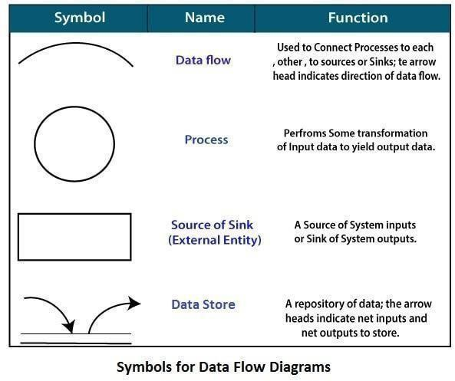
Diagram analysis and are shown in fig:

Level 0 DFD
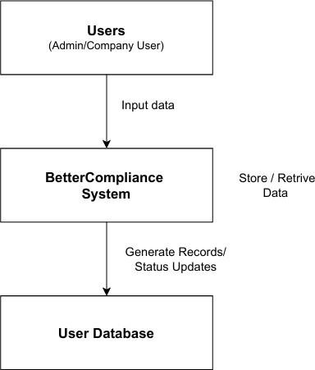

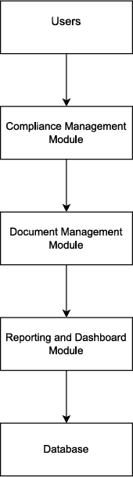
Level 1 DFD

PLANNING
6.1 Resource Estimation
The resource estimation for the Biggr Mobile Application focuses on evaluating and allocating the key human, technical, and financial resources needed to ensure smooth and efficient project execution. This stage is critical to guarantee that every component of the development process — from design to deployment — is properly supported. The primary goal is to ensure that sufficient resources are available at each phase, preventing delays, cost overruns, or quality compromises. Resource planning enables efficient teamwork, cost control, and timely completion of deliverables

6.1.1 Human Resources
The human resources required for the project include a diverse and skilled team. A Project Manager will oversee the overall development process, ensuring coordination and timely progress. A Frontend Developer will work on the React Native mobile interface for both Android and iOS platforms, while a Backend Developer will develop the server-side logic using Node.js and Express.js. A Database Administrator (DBA) will manage MongoDB, ensuring secure and efficient data storage. Additionally, a UI/UX Designer will craft a modern and user-friendly interface, and a QA Tester will ensure that the application is bug-free and optimized. A DevOps Engineer will handle deployment, automation, and continuous integration on cloud servers to maintain smooth operations.

6.1.2 Technical Resources
The hardware and software resources form the technological backbone of the project. Each developer requires a computer system with a minimum Intel i5 processor, 8 GB RAM, and stable internet connectivity. Android and iOS devices are essential for app testing and debugging. The key software stack includes React Native for the frontend, Node.js and Express.js for the backend, and MongoDB Atlas for the database. Development tools such as Visual Studio Code, Postman, and Figma will be used for coding, testing, and design, while GitHub will serve as the version control system.
6.2 Cost Estimation
Developing this system involves several costs categorized under development, API/integration, infrastructure, and maintenance. A detailed estimation is provided below:

6.2.1 Development Cost

Development can be done on standard laptops (already owned by the team), while testing can be performed on personal Android and iOS devices. Cloud hosting through free or low-cost plans on Render, AWS Free Tier, or MongoDB Atlas (Free Cluster) may cost around ₹3,000–₹5,000 per month, totaling ₹20,000–₹25,000 during the development phase

6.2.2 API & Integration Costs

For a small development team consisting of one Frontend Developer, one Backend Developer, a UI/UX Designer, and a QA Tester, the total manpower cost for 4–5 months would be approximately ₹6–8 lakhs, assuming freelance or entry-level developers are hired.

6.2.3 Infrastructure Cost

Since the project uses open-source technologies like React Native, Node.js, Express.js, and MongoDB, there are no major licensing fees. Tools such as Visual Studio Code, Postman, and GitHub (Free Tier) can be used at no additional cost. Minimal paid services like domain registration, Firebase notifications, and Figma (Pro) may add around ₹10,000–₹15,000 in total.

6.2.4 Maintenance Cost
Publishing costs include ₹2,000 (₹25 one-time) for Google Play Store and ₹8,000 (≈$99/year) for Apple Developer Account. Basic post-deployment maintenance and server monitoring may cost an additional ₹10,000–₹15,000 annually.
6.3 Software Engineering Paradigm
The project follows the Incremental Development Paradigm, which combines the structured nature of the Waterfall model with the flexibility of the Iterative approach. In this paradigm, the system is divided into smaller, manageable modules such as user authentication, document management, compliance tracking, and reporting. Each module is treated as an independent component that goes through all phases of the software development lifecycle including requirement analysis, design, coding, testing, and integration. Once a module is completed, it becomes part of the working system, allowing early deployment of functional parts even before the full system is complete. This approach allows continuous feedback from users and stake holders, helping developers identify issues and improve the system in each iteration. It also ensures that risks are minimized since errors can be detected and corrected early, rather than at the end of the project. The incremental paradigm supports continuous integration, modular development, and scalability, which are ideal for complex systems like company compliance and document management dashboards. Additionally, it provides flexibility to adapt to changing user requirements or business needs during development, without disrupting the entire system. The paradigm leads to higher user satisfaction, faster delivery of essential features, and a more stable and maintainable final product. Another major advantage of the incremental model is its progressive enhancement approach, where each version of the system builds upon the previous one. This ensures that basic functionalities are delivered first, such as login and user management, followed by advanced modules like document workflows, compliance tracking, and reporting tools.
This gradual development allows the system to evolve over time while maintaining overall stability and quality. It also helps project managers to monitor progress, estimate timelines accurately, and control development costs effectively.
Furthermore, the incremental paradigm encourages collaboration among teams and better projectvisibility.Sincemodulesaredevelopedinparallelorsequentially, team scan focus non specific features without waiting for other components to be fully completed. This improves productivity and ensures smooth integration at later stages. Regular testing after each increment guarantees that the system remains functional and free of critical bugs throughout development.
6.4 Scheduling
- Project scheduling is a crucial part of the software development process as it helps in planning, organizing, and tracking the progress of each phase within a defined time frame. The development of this system was divided into several stages, starting from requirement analysis to final deployment. In the first phase, the team gathered requirements, defined the project scope, and prepared the Software Requirement Specification (SRS). The next stage focused on system design, including database structure, architecture, and interface layout. Once the design was finalized, the development process began in two major parts: frontend and backend.
- The frontend development involved creating interactive pages, dashboards, and forms for users to easily manage data.
At the same time, the backend team worked on implementing server-side logic, authentication, and database connectivity. After both sides were completed, integration and testing were carried out to ensure that all modules worked correctly together. Testing was performed at each level to detect and fix any issues early. Finally, the system was deployed and monitored to ensure stability and performance.
- This project followed an incremental scheduling approach, where each module such as authentication, document management, compliance tracking, and reporting was developed and tested one after another. This allowed the team to deliver working features early and make improvements continuously. The entire project was completed over several weeks, with proper coordination between design, development, testing, and deployment phases.
- Such structured scheduling helped the team manage time effectively, maintain quality, and deliver a reliable and efficient system.

6.4.1 PERT Chart
The PERT chart is used to represent these quince of tasks and their dependencies in the
project. It helps identify which activities can be done in parallel and which depend on others.
The PERT (Program Evaluation and Review Technique) chart is used to plan and analyze the sequence of project tasks. It shows the relationship between activities, their dependencies, and the overall project flow.Thishelpsinidentifyingthecriticalpath—the longest chain of dependent tasks that determine the total project duration. In this project, tasks like analysis, design, development, and testing are arranged to ensure smooth progress and timely completion.
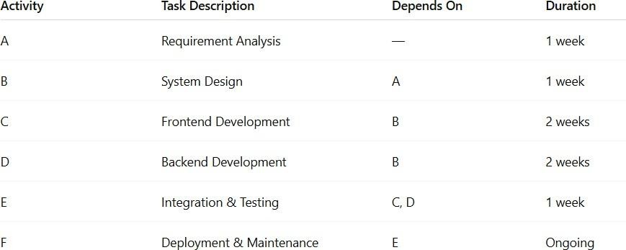
Activities and Dependencies:

6.4.2 Gantt Chart
The Gantt chart shows the timeline of all activities over the project duration. It visually represents when each task starts and ends, making tracking easier.
The Gantt chart visually represents the project schedule overtime. It displays each task as a horizontal bar, showing its start and end dates along a timeline. This helps track progress, allocate resources, and identify overlapping or dependent activities. In this project, the Gantt chart illustrates how phases like analysis; design, development, testing, and deployment are planned and executed step by step.
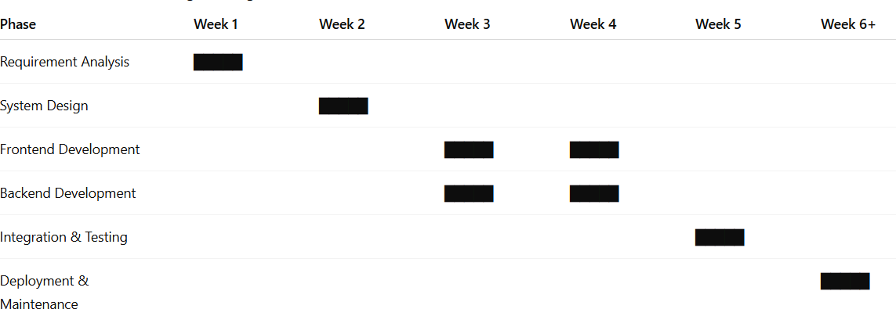

6.5 System Requirements Specifications (SRS)
The Software Requirements Specification (SRS) for the Biggr Mobile Application outlines the functional and non-functional requirements for developing a MERN-based (MongoDB, Express, React Native, Node.js) grocery delivery system that connects customers, vendors, delivery partners, and administrators on a unified digital platform. The application enables users to browse and search grocery items, manage carts, place orders, make secure payments, and track deliveries in real time. Vendors can manage their inventory, update product listings, and monitor sales, while administrators can oversee users, vendors, orders, and promotional activities through a centralized dashboard. The system integrates secure authentication using JWT, online payments through Razorpay or Stripe, and route tracking via Google Maps API. It is designed to ensure performance efficiency, data security, scalability, and user convenience, supporting up to 100,000 users concurrently with 99.5% uptime. Non-functional requirements emphasize usability, maintainability, reliability, and compliance with India’s DPDP Act and GDPR standards. Built for both Android and iOS, Biggr aims to deliver a fast, reliable, and seamless online grocery shopping experience with features like push notifications, multilingual support, and automated backups, forming the foundation for future upgrades such as AI-based recommendations, subscription deliveries, and loyalty programs.

User Class and Role
- Customer: The end user who browses, orders, pays for, and tracks grocery deliveries through the Biggr mobile app.
- Vendor: The store partner responsible for managing product listings, inventory, pricing, and fulfilling customer orders.
- Delivery Partner: The rider who picks up orders from vendors and delivers them to customers, updating live status and proof of delivery.
- Administrator: The system controller who manages users, vendors, orders, payments, and ensures smooth platform operations and compliance.

6.5.1 Functional Requirements
- User Registration and Login:
- Users can sign up using email, phone number, or OTP verification.
- Secure login with JWT-based authentication.
- Product Browsing:
- Users can search and filter products by category, price, or brand.
- Vendors can add or update products in real time.
- Cart and Checkout:
- Customers can add, update, or remove items from the cart.
- Checkout includes delivery address selection and payment options.
- Payment Gateway Integration:
- Supports UPI, card, and wallet payments through Razorpay or Paytm.
- Order Tracking:
- Users can track delivery status in real time.
- Delivery partners can update order progress.
- Admin Controls:
- Admin can manage products, users, vendors, and delivery operations.
- Notifications:
- Push notifications for order confirmation, updates, and promotions.

6.5.2 Non-Functional Requirements
The Biggr application must perform efficiently under varying user loads and network conditions. Page loading time should not exceed 3 seconds under normal usage, and server responses should occur within 2–3 seconds for major transactions like login, checkout, and order tracking. The backend should handle at least 1,000 concurrent users with minimal latency using Node.js and MongoDB’s scalable architecture. The database queries must be optimized with proper indexing, and caching mechanisms (like Redis) can be used to improve data retrieval speed.

2. Security Requirements
Security is critical for an e-commerce platform like Biggr. All communication between the app, server, and payment gateway must be encrypted using HTTPS (SSL/TLS). User passwords should be hashed using bcrypt or argon2, and authentication is handled through JWT (JSON Web Token) for session management. Sensitive information such as payment data must comply with PCI DSS standards, while personal data must follow the DPDP Act 2023 for privacy compliance. Access control should be role-based, preventing unauthorized users from accessing restricted modules.

3. Scalability Requirements
Biggr must be designed to handle increasing workloads as the user base and order volume grow. The backend architecture should support horizontal scaling (adding more servers) and vertical scaling (increasing server capacity). Using cloud hosting platforms like AWS or Google Cloud, the system can dynamically allocate resources based on demand. The database (MongoDB Atlas) should support sharding for efficient distribution of data across multiple nodes, ensuring continuous performance as traffic grows.

4. Usability Requirements
The application must offer an intuitive and seamless user experience for customers, vendors, and delivery agents. The user interface should be simple, responsive, and consistent, designed using React Native with accessibility standards (font size, contrast, and touch-friendly components). Navigation between pages should be smooth, and user actions like adding to cart, checkout, and order tracking must be clearly guided. A minimal learning curve should allow new users to operate the app easily without technical assistance.

5. Reliability Requirements
The system must ensure continuous operation and data integrity even in case of unexpected failures. The application should maintain 99.5% uptime and include auto-backup and recovery mechanisms for database protection. Critical modules like payment processing and order tracking must have retry mechanisms to recover from temporary errors. The use of cloud infrastructure ensures redundancy and failover capabilities, maintaining service availability during high traffic or server downtime.

6. Maintainability Requirements
The codebase should be modular, well-documented, and structured for easy updates and maintenance. The project must use version control (GitHub) to track changes and support continuous integration/deployment (CI/CD) through tools like GitHub Actions. The use of reusable components, standardized naming conventions, and separation of concerns between frontend, backend, and database layers will make maintenance and future enhancements easier.

7. Availability Requirements
Biggr must be accessible 24/7, especially since grocery orders can occur at any time of day. The system should rely on cloud-based hosting with load balancing and monitoring tools (such as PM2 or Datadog) to ensure uninterrupted service. Scheduled maintenance windows must be minimal and communicated to users in advance to avoid inconvenience.

8. Portability Requirements
The application should function across multiple devices and platforms, including Android and iOS, using a single React Native codebase. It should also be deployable on multiple cloud providers with minimal configuration changes. The backend APIs should remain platform-independent, making the system adaptable to web or desktop versions in the future.

9. Data Integrity Requirements
All transactions, such as payments, order updates, and user information changes, must maintain integrity throughout the system. The application should use atomic database operations to ensure data consistency, even during concurrent updates or failures.

10. Compliance Requirements
Biggr must comply with applicable legal and regulatory standards, including FSSAI labeling norms (for listed groceries), GST invoicing, and data protection laws. It should also meet international e-commerce best practices for security, accessibility, and payment handling.

SYSTEM DESIGN
The most creative and challenging face of the system development is System Design. It provides the understanding and procedural details necessary for implementing the system recommending in the feasibility study. Design goes through the logical and physicals tages of development. The main purpose of the design is to plan a solution for the problems specified in the requirement document
7.1 Input Design
The Input Design of the Biggr Mobile Application focuses on how users interact with the system to enter data accurately and efficiently. It ensures that all inputs provided by users—such as login details, product searches, and payment information—are captured clearly, validated properly, and processed securely. The design aims to make data entry simple, user-friendly, and error-free while maintaining consistency across all screens.

- User Registration and Login Inputs:
  - Fields: Name, Email, Mobile Number, Password/OTP.
  - Validation: Mandatory fields, valid email format, password strength check, and OTP verification.
  - Purpose: To securely identify users and provide personalized access.

- Product Search and Selection Inputs:
  - Fields: Search bar, category filters, price range, and brand selection.
  - Validation: Prevents empty search submissions and supports auto-suggestions.
  - Purpose: Helps users quickly find the desired grocery items.

- Cart and Checkout Inputs:
  - Fields: Quantity selection, delivery address, payment method, and coupon code.
  - Validation: Ensures valid quantities, verified address format, and correct payment details.
  - Purpose: To facilitate smooth order placement and payment processing.

- Vendor and Admin Inputs:
  - Fields: Product name, price, category, stock quantity, and image upload.
  - Validation: Ensures numeric validation for price and stock, and file type check for images.
  - Purpose: Allows vendors and admins to manage inventory accurately.

- Delivery Partner Inputs:
  - Fields: Order ID, delivery status updates (Picked, On Route, Delivered), and proof of delivery (photo/signature).
  - Validation: Mandatory order ID and proper status selection.
  - Purpose: To maintain accurate delivery tracking and order completion.

- Payment Inputs:
  - Fields: Card number, UPI ID, CVV, and OTP.
  - Validation: Follows PCI-DSS standards, ensuring data encryption and secure authentication.
  - Purpose: Enables safe and successful online transactions
7.2 Output Design

The Output Design of the Biggr Mobile Application focuses on how the system displays information to users in a clear, structured, and meaningful way. It ensures that the results generated from user inputs — such as order details, payment confirmation, and delivery updates — are presented in a readable and visually consistent format. The primary goal is to make all system outputs informative, easy to interpret, and aligned with user needs.
For customers, the output screens include dashboards showing product categories, personalized recommendations, order summaries, and live delivery tracking. After placing an order, users receive an invoice or confirmation message containing details like order ID, payment mode, delivery address, and estimated delivery time. The system also provides push notifications and alerts for order confirmation, shipment, and successful delivery, ensuring that users stay updated in real time.
For vendors and administrators, the system generates outputs such as sales reports, product stock summaries, and order management dashboards. These outputs help vendors monitor inventory levels, track daily sales, and manage pending orders efficiently. Admin outputs include user activity logs, revenue analytics, and delivery performance charts that support better business decision-making and operational control.Fordelivery partners, the output includes a list of assigned deliveries, pickup and drop locations, contact details, and route maps. Each delivery update, such as “Picked Up” or “Delivered,” is reflected in real time. Across all modules, the outputs are designed to be visually clean, accessible, and responsive, allowing quick comprehension and action. Overall, the output design of Biggr ensures that every user—customer, vendor, admin, or delivery agent—receives accurate, relevant, and well-structured information, enhancing efficiency, communication, and satisfaction

USE CASE DIAGRAM
A Use Case Diagram is a vital tool in system design, it provides a visual representation of how users interact with a system. It serves as a blueprint for understanding the functional requirement sofa system from a user’s perspective, aiding in the communication between stakeholders and guiding the development process.

Notations
Actors: They are external entities that interact with the system. These can include users, other systems, or hardware devices. In the context to a Use Case Diagram, actors initiate use cases and receive the outcomes. Proper identification and understand in go factors are crucial for accurately modeling system behavior.

Use case: They are like scenes in the play. They represent specific things your system can do. In the online shopping system, examples of use cases could be “Place Order,” “Track Delivery,” or “Update Product Information”. Use cases are represented by ovals.

System boundary: It is a visual representation of the scope or limits of the system you are modeling. It defines what is inside the system and what is outside. The boundary helps to establish a clear distinction between the elements that are part of the system and those that are external to it. The system boundary is typically represented by a rectangular box that surrounds all the use cases of the system.

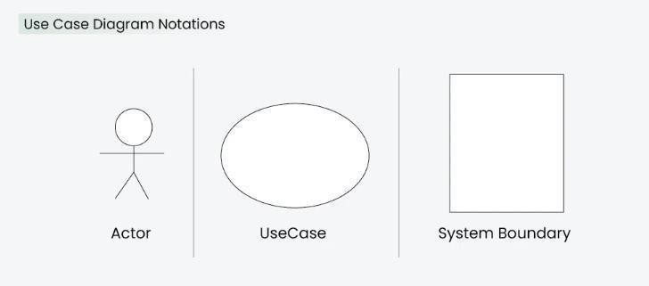

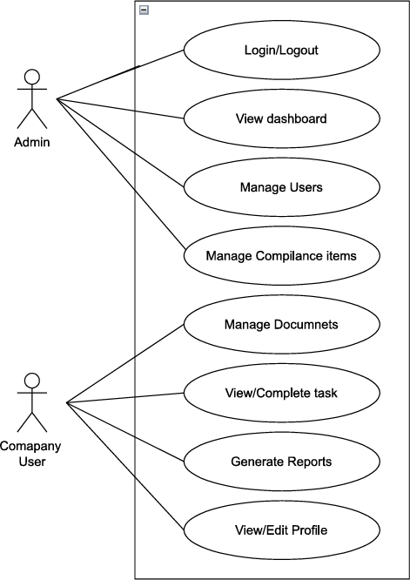

7.3 Database Design
The database design of the Biggr Mobile Application is based on a NoSQL model using MongoDB, chosen for its flexibility, scalability, and ability to handle large amounts of unstructured data. The database is organized into multiple collections representing various modules of the system such as users, products, orders, payments, and inventory. Each collection stores data in JSON-like documents, allowing for fast access, easy updates, and smooth integration with the backend API built on Node.js and Express.js.

The Users Collection stores essential details like user ID, name, contact information, password (hashed), address, and role (customer, vendor, admin, or delivery partner). The Products Collection includes product details such as product ID, name, category, price, stock availability, and images. The Orders Collection records order information like order ID, user ID, product details, payment ID, order status, delivery address, and timestamps for tracking. The Payments Collection stores transaction-related information such as payment ID, order ID, amount, payment method, and status (success, failed, refunded). The Inventory Collection maintains stock details for vendors, including product ID, available quantity, price, and last update time.

To enhance performance, indexes are created on commonly searched fields such as product name, category, user ID, and order ID, enabling faster query execution. Relationships between collections are maintained through reference IDs, for example, user IDs in the orders collection and product IDs in the inventory collection. Denormalization is used selectively to optimize speed for frequent operations such as viewing the cart or fetching recent orders.
Table Structure:
A data table is arranging of cells in which you can change values in some of the cells and come up with different answers to a problem.
User Table
Field Name | Data Type | Description
user_id | ObjectId | Unique ID for each user
name | String | Full name of the user
email | String | User’s email address
phone | String | Registered mobile number
password | String | Encrypted password
role | String | User role (Customer/Vendor/Admin/Delivery)
address | Array | List of saved addresses with location info
created_at | Date | Account creation timestamp

Vendors Table

Field Name | Data Type | Description
vendor_id | ObjectId | Unique vendor identification number
vendor_name | String | Name of the store/vendor
email | String | Vendor’s email address
phone | String | Contact number
gst_number | String | Registered GST number
address | String | Shop or warehouse address
active_status | Boolean | Indicates if vendor is active
created_at | Date | Vendor account creation date

Categories Table

Field Name | Data Type | Description
category_id | ObjectId | Unique category ID
category_name | String | Name of the grocery category
parent_id | ObjectId | Parent category (if any)
created_at | Date | Timestamp of creation
product_id | ObjectId | Unique product ID
vendor_id | ObjectId | Linked vendor/store ID
name | String | Product name
category_id | ObjectId | Associated category ID
brand | String | Product brand name
price | Number | Selling price
mrp | Number | Maximum retail price
stock | Number | Available quantity

Inventory Table

Field Name | Data Type | Description
inventory_id | ObjectId | Unique ID for each inventory entry
vendor_id | ObjectId | Vendor who manages the stock
product_id | ObjectId | Linked product ID
stock_quantity | Number | Quantity in stock
updated_at | Date | Last update timestamp

Cart Table

Field Name | Data Type | Description
cart_id | ObjectId | Unique ID for each cart
user_id | ObjectId | Linked user ID
items | Array | List of products with quantity and price
total_price | Number | Total price of all items
updated_at | Date | Last updated date

Orders Table
Field Name | Data Type | Description
order_id | ObjectId | Unique order ID
user_id | ObjectId | ID of the customer
vendor_id | ObjectId | ID of the vendor
items | Array | List of products ordered
total_amount | Number | Total payable amount
payment_id | ObjectId | Linked payment record
order_status | String | Status (Created, Paid, Delivered, Cancelled)
address | String | Delivery address
created_at | Date | Order creation date

Payments Table

Field Name | Data Type | Description
payment_id | ObjectId | Unique payment ID
order_id | ObjectId | Linked order ID
amount | Number | Total amount paid
payment_method | String | UPI, Card, Wallet, or COD
transaction_id | String | Gateway transaction reference
status | String | Payment status (Success/Failed/Refunded)
created_at | Date | Transaction date

Delivery Table

Field Name | Data Type | Description
delivery_id | ObjectId | Unique delivery record ID
order_id | ObjectId | Associated order ID
rider_id | ObjectId | Assigned delivery partner
route | String | Delivery route or area
delivery_status | String | Status (Assigned, Picked, Delivered)
delivery_time | Date | Timestamp of delivery completion

Coupons Table

Field Name | Data Type | Description
coupon_id | ObjectId | Unique coupon ID
code | String | Coupon code string
discount_type | String | Type (Flat/Percentage)
discount_value | Number | Discount amount/value
min_order_value | Number | Minimum order required
expiry_date | Date | Coupon expiry date
active | Boolean | Coupon availability status

Notifications Table

Field Name | Data Type | Description
notification_id | ObjectId | Unique ID
user_id | ObjectId | Receiver of the notification
message | String | Notification text
type | String | Type (Order, Offer, Payment, Alert)
status | String | Read/Unread
created_at | Date | Timestamp of notification

7.4 ER Diagram
ER Model stands for Entity Relationship Model is a high-level conceptual data model diagram. ER model helps to systematically analyze data requirements to produce a well- designed database. The ER Model represents real-world entities and the relationships between them.

ER Diagrams Symbols & Notations

Entity Relationship Diagram Symbols & Notations mainly contains three basic symbols which are rectangle, oval and diamond to represent relationships between elements, entities and attributes. There are some sub-elements which are based on main elements in ERD Diagram. ER Diagram is a visual representation of data that describes how data is related to each other using different ERD Symbols and Notations.
Following are the main components and its symbols in ER Diagrams:

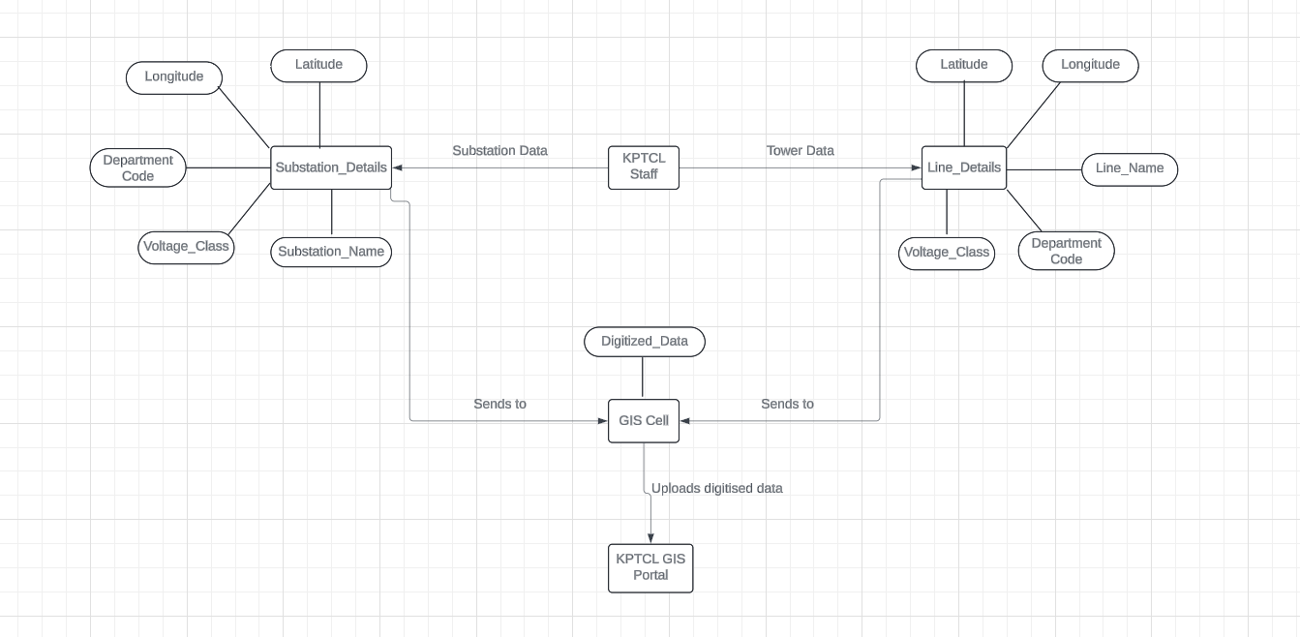
7.5 Modularization Details
The Biggr Grocery Delivery System is designed with a modular architecture to ensure scalability, maintainability, and ease of development. Each module is responsible for a specific functionality, making the system more organized and easier to enhance or debug. Below are the main modules of the project:

1. User Module
This module manages all activities related to users, including registration, login, profile management, and authentication. Users can browse groceries, add them to the cart, and place orders securely. It also handles session management and password recovery through secure APIs.

2. Admin Module
The Admin module allows system administrators to oversee the entire platform. It manages inventory, product listings, pricing, category creation, and user management. Admins can monitor orders, delivery status, and generate reports for business insights.

3. Product Management Module
This module handles product details such as product name, category, price, image, description, and stock availability. It ensures that product data remains accurate and updated, enabling users to view real-time inventory while shopping.

4. Order Management Module
The Order Management module tracks orders from placement to delivery. It processes order details, payment confirmation, order status updates, and delivery scheduling. It also integrates with notifications to keep users informed about their order progress.

5. Delivery Module
This module manages delivery personnel and their assigned orders. It includes features for route optimization, delivery tracking, and order confirmation upon successful delivery. Delivery partners can update the order status directly through their interface.

6. Payment Module
This module manages secure online transactions using integrated payment gateways like Razorpay or Stripe. It ensures safe handling of sensitive payment data and provides multiple payment options like credit/debit cards, UPI, and wallets.

7. Feedback and Support Module
The Feedback and Support module enables users to provide reviews, ratings, and report issues. It helps improve service quality by analyzing customer feedback and resolving complaints efficiently.

8. Notification Module
This module is responsible for sending alerts and updates related to orders, payments, promotions, and delivery status. It uses push notifications and in-app alerts to keep users informed in real-time.

IMPLEMENTATION AND CODING GUIDELINES

The implementation of the Intern Task Management System involves converting the design and planned modules into a fully functional software system. The project follows a client-server architecture, where the frontend is developed using React (with Vite) and the backend is developed using FastAPI with SQLAlchemy ORM for database interactions. The system is implemented in a modular way to ensure scalability, maintainability, and ease of debugging.
8.1 Pseudo Code of the Project
Project Dashboard
import{Button}from"@/components/ui/button";
import{Card,CardContent,CardHeader,CardTitle}from"@/components/ui/card"; import { Input } from "@/components/ui/input";
import{Label}from"@/components/ui/label"; import {
Lock, Mail, Shield,
CheckCircle, Users, BarChart3,
}from"lucide-react";
import{useForm}from"react-hook-form";
import{zodResolver}from"@hookform/resolvers/zod"; import { z } from "zod";
import{useAuth}from"@/hooks/api/useAuth"; import { toast } from "sonner";
import{loginSchema}from"@/lib/validations/login";
typeLoginFormData=z.infer<typeofloginSchema>;
exportconstLoginPage=()=>{
const{login,isLoggingIn}=useAuth();
const { register,

handleSubmit, formState:{errors}, setError,
} = useForm<LoginFormData>({ resolver:zodResolver(loginSchema), defaultValues: {
email:"",
password:"",
},
});
consthandleLogin=async(data:LoginFormData)=>{ try {
awaitlogin(data,{
onSuccess:()=>toast.success("Loginsuccessful"), onError: (error) => {
consterrorMessage=
error?.message||"Loginfailed.Pleasecheckyourcredentials."; setError("root", { type: "manual", message: errorMessage }); toast.error(errorMessage);
},
});
}catch(error) {
consterrorMessage=
errorinstanceofError?error.message:"Anunexpectederroroccurred"; setError("root", { type: "manual", message: errorMessage }); toast.error(errorMessage);
}
};
return(

<divclassName="min-h-screenbg-gradient-to-brfrom-primary/5via-backgroundto-accent/5 flex items-center justify-center p-4">
<div className="absoluteinset-0 bg-gradient-overlayopacity-50"></div>
<div className="relativez-10w-fullmax-w-6xl gridlg:grid-cols-2gap-8 items-center">
{/*LeftSide-Branding*/}
<divclassName="hidden lg:blockspace-y-8">
<divclassName="animate-fade-in">
<divclassName="flexitems-centerspace-x-3mb-8">
<divclassName="w-12h-12bg-gradient-primaryrounded-xlflexitems-centerjustify- center shadow-glow">
<Shield className="w-6h-6text-white" />
</div>
<div>
<h1className="text-3xlfont-boldtext-foreground">BetterCompliance
</h1>
<pclassName="text-muted-foreground">Business Compliance Management
</p>
</div>
</div>
<h2className="text-4xlfont-boldtext-foregroundmb-6leading-tight"> Streamline Your Business{" "}
<spanclassName="bg-gradient-primarybg-clip-texttext-transparent">Compliance
</span>
</h2>
<pclassName="text-lgtext-muted-foregroundmb-8leading-relaxed">

Manageyourcompanydocuments,trackcompliancerequirements,andensure regulatory adherence with our comprehensive platform.
</p>
<divclassName="space-y-4">
<div
className="flexitems-centerspace-x-3animate-slide-up" style={{ animationDelay: "0.1s" }}
>
<divclassName="w-10h-10bg-success/10rounded-lgflexitems-center justify-center">
<CheckCircleclassName="w-5h-5text-success" />
</div>
<div>
<p className="font-medium text-foreground">Document Management
</p>
<p className="text-sm text-muted-foreground">Secure upload and processing
</p>
</div>
</div>
<div
className="flexitems-centerspace-x-3animate-slide-up" style={{ animationDelay: "0.2s" }}
>
<divclassName="w-10h-10bg-info/10 rounded-lg flex items-centerjustify-center">
<UsersclassName="w-5h-5text-info"/>
</div>
<div>
<pclassName="font-mediumtext-foreground">
Multi-Company Support
</p>
<p className="text-sm text-muted-foreground">Manage multiple businesses
</p>
</div>
</div>
<div
className="flexitems-centerspace-x-3animate-slide-up" style={{ animationDelay: "0.3s" }}
>
<divclassName="w-10h-10bg-warning/10 rounded-lgflex items-centerjustify-center">
<BarChart3className="w-5h-5text-warning"/>
</div>
<div>
<p className="font-medium text-foreground">Real-time Tracking
</p>
<p className="text-sm text-muted-foreground">Monitor compliance status
</p>
</div>
</div>
</div>
</div>
</div>
{/*RightSide-LoginForm*/}
<divclassName="animate-scale-in">
<Card className="backdrop-blur-smbg-card/95shadow-largeborder-0">
</div>
)}
<divclassName="space-y-2">
<LabelhtmlFor="email"className="text-smfont-medium"> Email Address <span className="text-red-500">*</span>
</Label>

<CardHeaderclassName="space-y-4pb-8">
<divclassName="text-center lg:hidden">
<div className="flexitems-centerjustify-center space-x-3mb-4">
<divclassName="w-10h-10bg-gradient-primaryrounded-lgflexitems-centerjustify- center">

<divclassName="relative">
<MailclassName="absoluteleft-3top-1/2transform-translate-y-1/2text-muted- foreground h-4 w-4" />
<Input id="email" type="email"
placeholder="admin@compliancehub.com"
className="pl-10h-12bg-background/50border-border/50focus:border-primaryfocus:ring-primary/20"
disabled={isLoggingIn}
{...register("email")} autoComplete="username"
/>
</div>
{errors.email&&(
<pclassName="text-smtext-red-500">
{errors.email.message}
</p>
)}
</div>
<divclassName="space-y-2">
<LabelhtmlFor="password"className="text-smfont-medium"> Password <span className="text-red-500">*</span>
</Label>
<divclassName="relative">
<LockclassName="absoluteleft-3top-1/2transform-translate-y-1/2text-muted- foreground h-4 w-4" />
<Input id="password" type="password"
placeholder="Enteryourpassword"
className="pl-10h-12bg-background/50border-border/50focus:border-primaryfocus:ring-primary/20"
disabled={isLoggingIn}
{...register("password")} autoComplete="current-password"
/>
</div>
{errors.password&&(
<pclassName="text-smtext-red-500">
{errors.password.message}
</p>
)}
</div>

<Button type="submit"
className="w-fullh-12bg-gradient-primarytext-whitefont-mediumshadow-glow hover:shadow-lg transition-all duration-200"
disabled={isLoggingIn}
>
{isLoggingIn?"Signingin...":"SignIn"}
</Button>
</form>
</CardContent>
</Card>
</div>
</div>
</div>
);
};

CompanyOverview.tsx
import{Button}from"@/components/ui/button";
import{Card,CardContent,CardHeader,CardTitle}from"@/components/ui/card";
import { StatusBadge } from "../StatusBadge";
import { FileText, Download, CheckCircle, Clock, AlertCircle, Phone,
Mail, Globe, Calendar,
}from"lucide-react";
import{useParams}from"react-router-dom"; import { useMemo } from "react";
import{useQuery}from"@tanstack/react-query";
import{companyService}from"@/services/api/companyService"; import type { Company } from "@/Interface/company";
exportconstCompanyOverview=()=>{ const{ id } = useParams();
const{data,isLoading,error}=useQuery({ queryKey: ["company", id],
queryFn:async()=>companyService.getCompanyById(idasstring), enabled: Boolean(id),
});
constcompany=useMemo(()=>{
constc=data?.dataasCompany|undefined; if (!c) return undefined;
return{
...c,
companyRegistrationDate:c.companyRegistrationDate
?(newDate(c.companyRegistrationDateasunknownasstring)asunknownasDate)
:(undefinedasunknownasDate),
createdAt: c.createdAt ? (new Date(c.createdAt) as unknown as string) :c.createdAt, updatedAt:c.updatedAt?(newDate(c.updatedAt)asunknownasstring):c.updatedAt,
}asunknownas(Company&{createdAt?:Date;updatedAt?:Date});
},[data]);
if(isLoading){
return<div>Loadingcompanyoverview...</div>;
}
if(error||!company){
return <divclassName="text-destructive">Failedto loadcompanyoverview.</div>;
}
return(
<divclassName="space-y-6">
{/*CompanyHeader*/}
<divclassName="flexitems-centerjustify-between">
<div>
<h2className="text-xlfont-boldtext-foreground">{company.name}</h2>
<divclassName="flexitems-centerspace-x-4mt-2">
<spanclassName="text-muted-foreground">#{company.cin}</span>
<StatusBadgestatus={company.status}/>
</div>
</div>
<ButtonclassName="bg-primarytext-primary-foregroundhover:bg-primary/90">
<DownloadclassName="w-4h-4mr-2"/> Export Report
</Button>
</div>
{/*CompanyDetailsGrid*/}
<div className="gridgrid-cols-1md:grid-cols-3 gap-6">
<Card>
<CardHeader>
<CardTitleclassName="text-basefont-semibold">CompanyDetails</CardTitle>
</CardHeader>
<CardContentclassName="space-y-3">
<div>
<pclassName="text-sm text-muted-foreground">Category</p>
<p className="font-medium">{company.category||"-"}</p>
</div>
<div>
<pclassName="text-smtext-muted-foreground">Sub-category</p>
<pclassName="font-medium">{company.subCategory||"-"}</p>
</div>
<divclassName="flexitems-center">
<CalendarclassName="w-4h-4mr-2text-muted-foreground"/>
<div>
<pclassName="text-smtext-muted-foreground">Registration</p>
<pclassName="font-medium">
{company.companyRegistrationDate
? (company.companyRegistrationDateasunknown asDate).toLocaleDateString()
:"-"}
</p>

</div>
</div>
<div>
<pclassName="text-sm text-muted-foreground">ROC</p>
<pclassName="font-medium">{company.roc||"-"}</p>
</div>
</CardContent>
</Card>
<Card>
<CardHeader>
<CardTitleclassName="text-basefont-semibold">Tax &Registrations</CardTitle>
</CardHeader>
<CardContentclassName="space-y-3">
<div>
<pclassName="text-sm text-muted-foreground">PAN</p>
<pclassName="font-medium">{company.pan||"-"}</p>
</div>
<div>
<pclassName="text-sm text-muted-foreground">GSTIN</p>
<divclassName="space-y-1">
{(company.gst||[]).length===0&&<pclassName="font-medium">-</p>}
{(company.gst||[]).slice(0,2).map((gst,idx)=>(
<pkey={idx}className="font-medium">{gst}</p>
))}
{(company.gst||[]).length>2&& (
<pclassName="text-xstext-muted-foreground">
+{(company.gst||[]).length-2}more
</p>
)}
</div>
</div>
</div>
</CardContent>
</Card>
<Card>
<CardHeader>
<CardTitleclassName="text-basefont-semibold">ContactInformation</CardTitle>
</div>
<div>
<pclassName="text-sm text-muted-foreground">TAN</p>
<divclassName="space-y-1">
{(company.tan||[]).length===0&&<p className="font-medium">-</p>}
{(company.tan||[]).slice(0,2).map((tan,idx)=>(
<pkey={idx}className="font-medium">{tan}</p>
))}
{(company.tan||[]).length>2&&(
<pclassName="text-xstext-muted-foreground">
+{(company.tan||[]).length-2}more
</p>
)}
</div>
</div>
<divclassName="gridgrid-cols-2gap-4">
<div>
<pclassName="text-smtext-muted-foreground">EPF</p>
<p className="font-medium">{company.epf||"-"}</p>
</div>
<div>
<pclassName="text-smtext-muted-foreground">ESI</p>
<pclassName="font-medium">{company.esi||"-"}</p>
>
</CardHeader>
<CardContentclassName="space-y-3">
<divclassName="flexitems-center">
<PhoneclassName="w-4h-4mr-2 text-muted-foreground"/>
<div>
<pclassName="text-smtext-muted-foreground">Phone</p>
<pclassName="font-medium">{company.phone||"-"}</p>
</div>
</div>
<divclassName="flexitems-center">
<MailclassName="w-4h-4mr-2text-muted-foreground" />
<div>
<pclassName="text-smtext-muted-foreground">Email</p>
<pclassName="font-medium">{company.email||"-"}</p>
</div>
</div>
{company.website&&(
<divclassName="flexitems-center">
<GlobeclassName="w-4h-4mr-2text-muted-foreground"/>
<a
href={company.website.startsWith("http")?company.website:
`https://${company.website}`}
target="_blank" rel="noopenernoreferrer"
className="font-medium text-primaryhover:underline"
>
{company.website.replace(/^https?:\/\//,"")}
</a>
</div>
)}
</CardContent>
</Card>
</div>
{/*RegisteredAddress*/}
<Card>
<CardHeader>
<CardTitleclassName="text-basefont-semiboldflex items-center">
<spanclassName="mr-2">•˙¡</span>RegisteredAddress
</CardTitle>
</CardHeader>
<CardContent>
<pclassName="text-foreground">{company.address||"-"}</p>
</CardContent>
</Card>
</div>
);
};

8.2 Coding Standards
To ensure the Biggr Grocery Delivery System is reliable, maintainable, and easy to scale, strict coding standards were followed throughout the development process. These standards improve readability, minimize errors, and promote consistent collaboration among developers.

1. Naming Conventions
- Variables and Functions: Use meaningful and descriptive names in camelCase format (e.g., userName, getProductList()).
- Classes and Components: Use PascalCase (e.g., UserProfile, OrderManager).
- Constants: Written in UPPERCASE_WITH_UNDERSCORES (e.g., MAX_ITEMS_PER_ORDER).
- Database Collections: Use plural lowercase names (e.g., users, orders, products).

2. Code Structure and Organization
Follow the MERN stack directory structure:
- /backend
- /models
- /routes
- /controllers
- /middlewares
- /frontend
- /components
- /screens
- /services
- Each module has separate files for routes, controllers, and models.

3. Commenting and Documentation
- Use JSDoc-style comments to describe functions and methods.
- Add inline comments for complex logic to aid understanding.
- Each file starts with a header comment specifying purpose, author, and date.
Example:
/**
* @file Handles product-related API routes
* @author Biggr Dev Team
* @date 2025-10-15
*/

4. Error Handling
- All APIs return standardized JSON responses with proper status codes.
- Use try-catch blocks for asynchronous operations to prevent crashes.
- Provide meaningful error messages for debugging and user feedback.

5. Code Formatting
- Maintain consistent indentation (2 or 4 spaces).
- Use Prettier and ESLint to ensure uniform style and detect syntax issues.
- Remove unused imports, variables, and console logs before deployment.

6. Security Practices
  - Sanitize user inputs to prevent SQL/NoSQL injection.
  - Use JWT (JSON Web Tokens) for authentication and session management.
  - Store passwords securely using bcrypt hashing.

7. Version Control and Collaboration
- Use Git for source control with meaningful commit messages.
- Follow branching strategy:
- main → production-ready code
- dev → development version
- feature/* → individual features

8. Testing and Validation
- Write unit and integration tests for critical modules.
- Use Jest for backend and React Native Testing Library for frontend tests.
- Ensure 100% test pass rate before deployment.
8.3 Validation Checks
Validation checks play a crucial role in maintaining data integrity, ensuring secure transactions, and providing a seamless user experience in the Biggr Grocery Delivery System. Proper validation prevents incorrect, incomplete, or malicious data from entering the system, thereby improving accuracy and reliability.
1. User Registration and Login Validation
- Email Validation: Ensures the entered email follows a valid format (e.g., example@domain.com).
- Password Validation: Requires a minimum length (8 characters) and a mix of letters, numbers, and symbols.
- Mobile Number Validation: Checks for a valid 10-digit numeric input.
- Duplicate Account Prevention: System checks if an email or phone number already exists in the database.
- Authentication Token Validation: Validates JWT tokens before accessing secured routes.

2. Product Management Validation
- Product Name: Must not be empty or contain only special characters.
- Price Field: Accepts only numeric values greater than zero.
- Stock Quantity: Must be a non-negative integer.
- Category Selection: Ensures each product belongs to a valid category before saving.
- Image Upload: Validates file format (only JPG/PNG) and maximum file size.

3. Order Placement Validation
- Cart Validation: Checks that the cart is not empty before placing an order.
- Delivery Address: Ensures that the user provides a valid address with city and postal code.
- Payment Method: Verifies that a valid payment option (UPI, card, or COD) is selected.
- Order Confirmation: System validates inventory before finalizing the order to avoid out-of-stock errors.

4. Payment Validation
- Transaction Amount: Matches the total cart value with the payment request.
- Payment Gateway Response: Validates success or failure response from Razorpay/Stripe API.
- Data Encryption: Ensures sensitive information (like card details) is securely encrypted.
- Order Status Update: Payment completion triggers automatic update of order status.

5. Admin Panel Validation
- Admin Login Credentials: Only authorized admins can access the panel using valid credentials.
- Product and Category Management: Checks for duplicate entries before adding new items.
- Input Restrictions: Prevents empty or invalid data in product details or pricing fields.

6. Feedback and Support Validation
- User Input Validation: Ensures feedback messages are within character limits and free from harmful scripts.
- Rating Validation: Accepts only numeric values (1 to 5).
- Complaint Submission: Checks required fields (order ID, message) before submission.

SYSTEM TESTING
9.1 Testing Strategies
The System Testing phase of the Biggr Mobile Application ensures that the entire grocery delivery system performs as expected under real-world conditions and meets all functional and non-functional requirements. It involves verifying the end-to-end workflows of customers, vendors, delivery partners, and administrators. The process begins with unit and integration testing to validate components like authentication, cart management, and APIs, followed by full system and regression testing to ensure overall stability after updates. Testing is performed on both Android and iOS devices under various network conditions using tools such as Jest, Postman, and JMeter. Functional testing covers areas like user login, product search, checkout, payment integration, and delivery tracking, while non-functional testing focuses on performance, reliability, usability, and security. Security testing ensures encrypted communication, role-based access control, and data privacy compliance. The testing environment mirrors production settings, using test databases and payment gateways. Each test case follows defined entry and exit criteria, aiming for 95% pass rates and zero high-severity defects. After successful verification, the system undergoes User Acceptance Testing (UAT) for stakeholder approval. Overall, system testing guarantees that Biggr is robust, user-friendly, secure, and performs efficiently under high load, delivering a smooth grocery ordering and delivery experience.
9.2 Test Plan
The Test Plan for the Biggr Mobile Application defines the overall approach, objectives, and execution strategy for ensuring that the grocery delivery system functions seamlessly across all modules and user roles. The main objective is to verify that each feature — including user registration, product browsing, cart management, payment, order tracking, vendor operations, and administrative control — performs accurately and reliably across Android and iOS devices. The testing scope covers functional, integration, performance, security, usability, and compatibility testing, ensuring the system delivers a smooth and secure user experience. Testing will follow an agile-based, iterative approach using tools such as Jest, Postman, JMeter, and Firebase Test Lab, with automated regression tests and manual exploratory testing conducted on multiple devices and network conditions. The test environment will replicate the production setup with MongoDB Atlas as the backend and third-party APIs for payments and maps. Entry criteria include a stable staging build and approved test cases, while exit criteria require 95% test success and zero critical defects. The QA team, along with developers and the project manager, will collaborate on executing test cases, logging issues, and verifying fixes. Key deliverables include test reports, defect logs, and a final test summary with UAT approval. The plan also addresses risks such as API failures, device compatibility, and schedule constraints, with mitigation strategies like mock APIs and prioritized testing. Overall, this test plan ensures that Biggr is thoroughly validated for functionality, performance, and security before deployment, guaranteeing a stable and user-friendly grocery delivery experience.
9.3 Test Cases
User Test cases

Area | Test Case | Preconditions | Steps | Expected Result
Auth | Login with OTP | User has valid phone | Request OTP → Enter correct code | User logged in; JWT issued; home shown
Auth | Block invalid OTP | — | Enter wrong OTP 3× | Error shown; rate-limit for next attempt
Profile | Add delivery address | Logged in | Open Address → Add new → Save | Address saved & selectable at checkout
Catalog | Search & filter | Logged in; products exist | Search “rice” → Filter brand/price | Relevant items listed; counts correct
Cart | Add/update/remove item | Logged in | Add item → change qty → remove | Cart totals update; remove clears line
Coupon | Apply valid coupon | Cart ≥ min value | Apply code at checkout | Discount applied; totals recalc; message shown
Coupon | Reject expired/invalid coupon | — | Apply invalid/expired code | Clear error; no discount applied
Payment | Successful online payment | Gateway test mode | Choose UPI → Pay success | Order created=PAID; receipt + confirmation
Payment | Failure & retry | Gateway test mode | Trigger failure → Retry | Order remains UNPAID; retry path available; no double charge
Tracking | Live order tracking | Order in OFD | Open Track screen | Stepper updates; ETA & rider contact visible

Admin Test cases

Area | Test Case | Preconditions | Steps | Expected Result
Auth/RBAC | Admin login & role guard | Admin user exists | Login → open /admin | Access granted; non-admins blocked
Vendors | Onboard vendor | KYC docs | Create vendor → upload KYC → Activate | Vendor status=Active; appears in lists
Catalog | Create & edit product | Vendor exists | Add product → set price/tax → Save | Product visible in catalog; searchable
Inventory | Update stock & pricing | Product exists | Set stock=0; update price | PDP shows OOS; price change reflected
Orders | View & manage orders | Orders exist | Open Orders → filter by status | Correct list; statuses accurate
Coupons | Create promo & validate | — | New coupon (min cart, expiry) | Coupon active; enforced at checkout
Reports | Export sales CSV | Data exists | Export Sales (this week) | Valid CSV with totals, UTC timestamps
Compliance | Download tax report | Invoices present | Generate GST report | File generated; figures match orders

Defect Report

Title | Severity | Status | Env | Steps to Reproduce | Actual vs Expected
Coupon applied after item removed recalculates wrong totals | P1 | Open | Staging/Android 13 | Add 2 items → apply coupon → remove one | A: Discount not recomputed; E: Recompute totals & discount
Payment success webhook processed twice | P1 | Fixed | Staging/API | Replay same webhook ID | A: Double capture attempt; E: Idempotent single update
Search debounce too aggressive on low-end devices | P2 | In Progress | Android 9 | Type quick query | A: Missed queries; E: Stable 300–400ms debounce
Rider ETA not updating on poor network | P2 | Open | iOS 15 | Toggle offline → back online | A: ETA stale; E: Backoff + retry to refresh ETA
Admin CSV export missing tax column | P2 | Fixed | Web/Chrome | Export weekly sales | A: No tax col; E: Include tax% & tax amount
OOS product still addable from cached PDP | P2 | Fixed | Android 12 | Open PDP offline → add | A: Adds to cart; E: Block with OOS message
OTP resend button active before timer | P3 | Fixed | iOS 16 | Login → resend OTP | A: Immediate resend; E: Enable after 30s
Push notif deep link opens wrong order | P3 | In Progress | Android 11 | Tap ‘Order shipped’ | A: Opens last order; E: Open orderId from payload

SYSTEM IMPLEMENTATION
System implementation refers to the process of installing and configuring the system into the user's environment, making it operational and ready for use. This stage involves several key activities, including system deployment, user training, and post-implementation support.

10.1 Implementation Strategies
- Phased Implementation: Biggr was launched in stages, beginning with a limited pilot rollout to a small user group for testing and feedback. Once stability and performance were validated, the system was gradually expanded to a full-scale deployment.
- Parallel Implementation: The new Biggr system initially ran alongside existing manual order processes to ensure accuracy and reliability. This allowed teams to compare results and ensure smooth business continuity before full migration.
- Data Migration and Configuration: Product, vendor, and user data were securely migrated to MongoDB Atlas after thorough validation and cleansing. All roles, permissions, and authentication mechanisms were configured to maintain consistency and security.
- User Training and Support: Comprehensive training sessions and documentation were provided to vendors, admins, and delivery partners before launch. A helpdesk and support system were established to resolve early operational issues.
- Continuous Monitoring and Feedback Integration: System performance was closely monitored through analytics and user feedback during the initial rollout. Regular updates and improvements were implemented to enhance user experience and stability.

10.2 Post Implementation
Post implementation refers to the period after the system has been deployed and includes the activities needed to maintain and support the system. This phase ensures that the system continues to work efficiently and evolves with the organization’s needs.
- System Monitoring: Continuous monitoring of app performance, uptime, and transaction logs using tools like Firebase and analytics dashboards.
- Bug Fixes and Maintenance: Identification and resolution of live issues or performance glitches through regular hotfixes and patch updates.
- User Support and Assistance: A dedicated helpdesk and support team handled user queries, vendor issues, and delivery partner concerns post-launch.
- Feedback Collection: Feedback from customers, vendors, and delivery agents was gathered through surveys, reviews, and in-app forms for future improvements.
- Performance Optimization: Regular updates were released to improve app loading speed, payment processing, and tracking accuracy.
- Security and Backup: Daily database backups, security audits, and data encryption measures were implemented to ensure protection and reliability.
- Reporting and Evaluation: Admin dashboards generated reports on order volume, customer satisfaction, and system performance for decision-making.
- User Training Continuation: Ongoing training sessions and tutorials helped new vendors and delivery partners adapt to updated features.
- System Scaling: Infrastructure and APIs were optimized to handle increasing users, transactions, and vendor data efficiently.
- Future Enhancements: Plans were initiated for introducing loyalty programs, subscription models, and AI-based product recommendations

SYSTEM SECURITY MEASURES
Security is a critical part of this system to protect sensitive company information, documents, and user data from unauthorized access or misuse. The system follows several security measures to ensure data integrity, confidentiality, and availability.
To start with, the system implements user authentication and authorization to make sure that only verified users can log in and access specific modules. Role-based access control ensures that each user can perform only the actions allowed by their role, such as admin, director, or staff member. Strong password policies and multi-factor authentication add an extra layer of protection to prevent unauthorized access.
All data transferred between the client and server is encrypted using secure protocols (HTTPS), ensuring that sensitive information like login credentials and documents cannot be intercepted during transmission. Additionally, data encryption at rest is used to protect information stored in the database. Regular security audits and vulnerability scans are performed to detect and fix potential threats before they can cause harm.
Thesystemalsoincludessessiontimeoutfeatures,whichautomaticallylogusersoutaftera period of inactivity to prevent misuse of unattended sessions. To ensure data reliability, dailybackupsare maintained, andadisasterrecovery planisinplace torestoredataincase of any system failure. Input validation and sanitization are applied throughout the application to protect against SQL injection, cross-site scripting (XSS), and other common web attacks.
Furthermore, logging and monitoring tools are used to track system activities and detect suspicious behavior in real time. Access logs help in identifying unauthorized attempts and maintaining accountability. The system also complies with standard data protection and privacy regulations such as GDPR, ensuring that user data is handled responsibly.
Overall, these security measures ensure that the system remains safe, stable, and trustworthy for all users, providing a secure environment for managing sensitive company data and documents.

SCREENSHOTS AND REPORTS
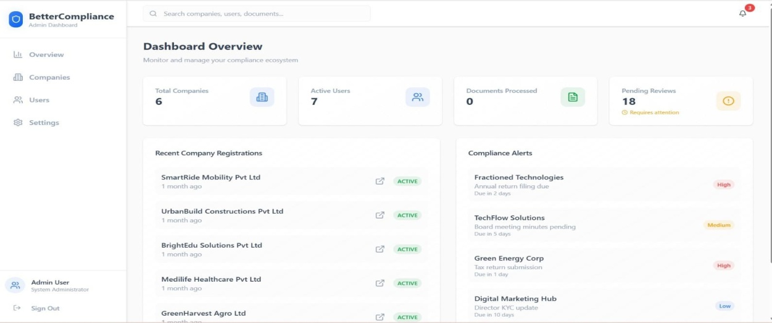
Dashboard Overviewpage:

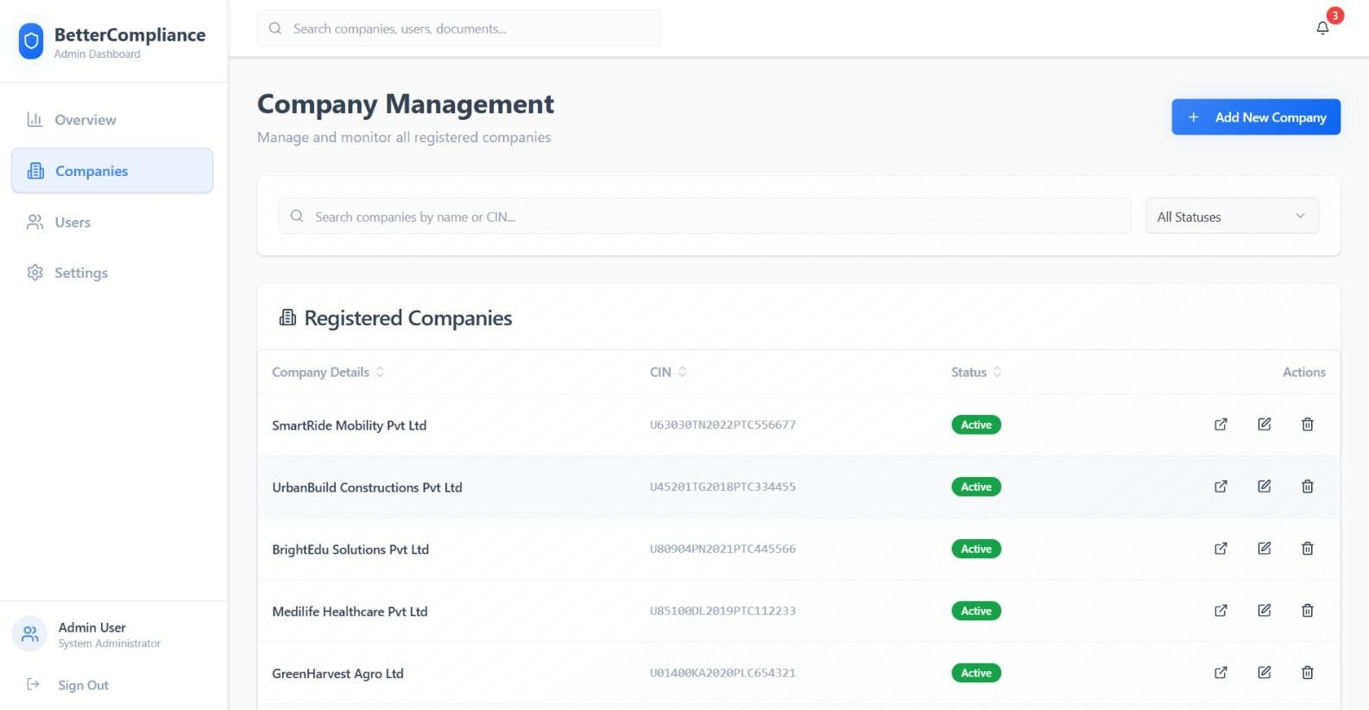
Company Management Page:

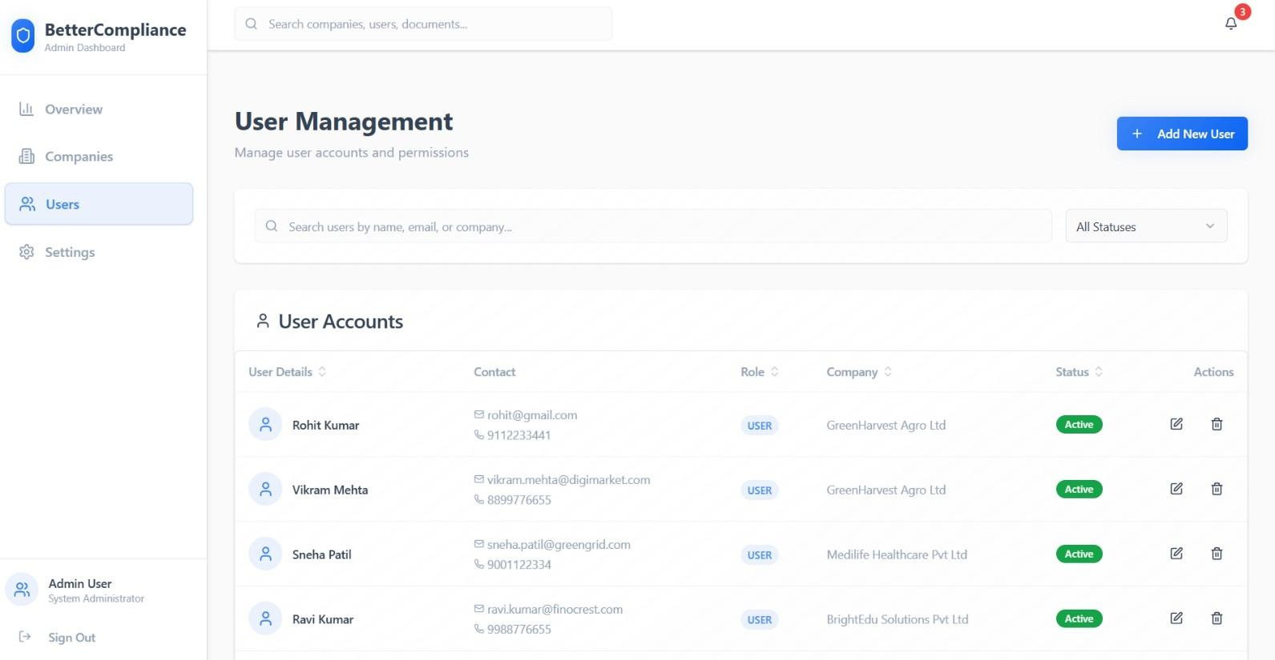
User Management Page:

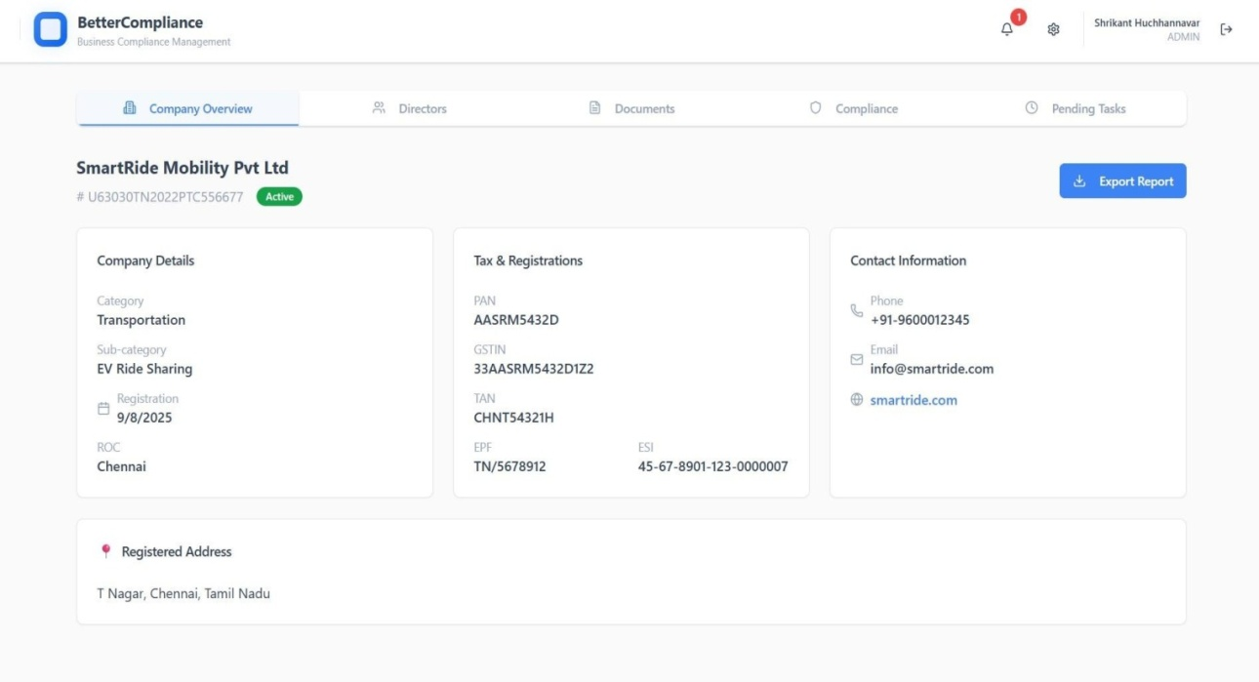
Company Overview Page:

Document Repository Page:
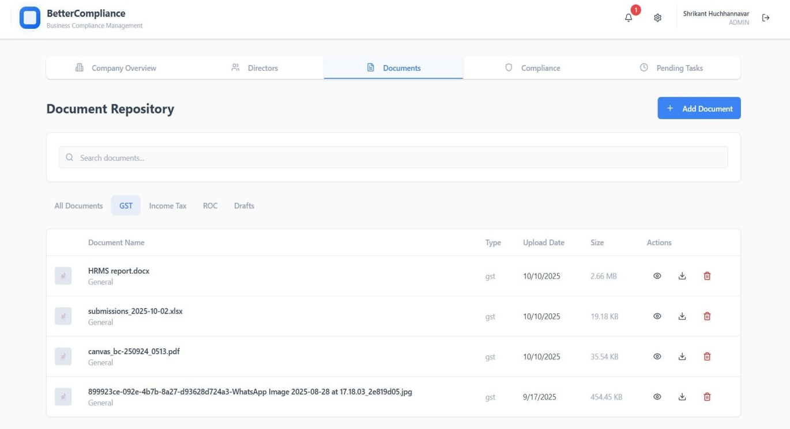

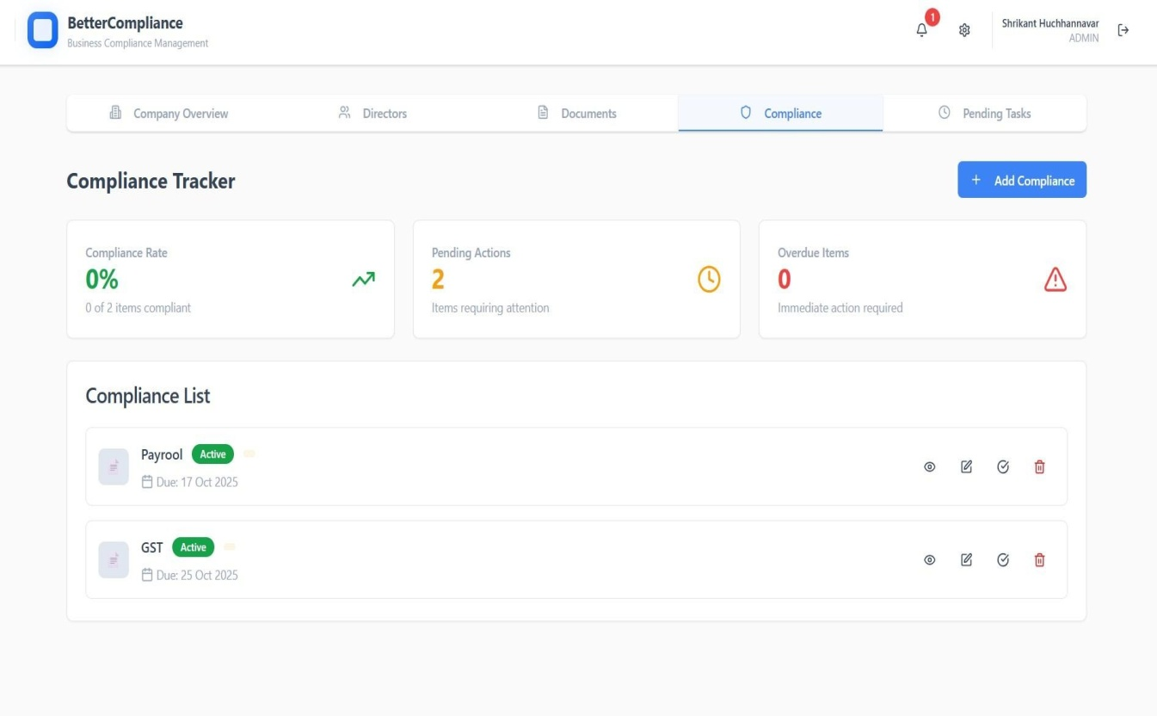
Compliance Tracker Page:

SCOPE FOR IMPROVEMENT
- Enhanced User Interface (UI): The app’s design can be further refined with more personalized layouts, improved navigation, and adaptive themes for a smoother user experience.
- AI-Based Recommendations: Integrating machine learning algorithms to suggest products based on user purchase history, preferences, and seasonal trends can boost engagement and sales.
- Subscription and Loyalty Programs: Implementing subscription models for recurring grocery deliveries and reward systems for loyal customers can increase retention and convenience.
- Voice Search Integration: Adding voice command functionality in multiple languages will make the app more accessible to a wider range of users.
- Offline Access Mode: Allowing users to browse cached product listings and prepare carts offline would enhance usability in low-network areas.
- Advanced Analytics Dashboard: Providing vendors and admins with more detailed analytics—like sales forecasting, delivery performance, and product demand trends—will aid better decision-making.
- Improved Delivery Partner Features: Enhancing the delivery partner app with live traffic updates, route optimization, and performance tracking can improve delivery efficiency.
- Customer Support Chatbot: Integrating an AI-driven chatbot for instant help and issue resolution will reduce response time and improve user satisfaction.
- Multi-Language and Regional Expansion: Adding more regional language support and local delivery zone integrations will help Biggr reach a broader customer base.
- Sustainability Initiatives: Introducing eco-friendly packaging options, carbon footprint tracking, and partnerships with green vendors can strengthen Biggr’s sustainability goals.

TOOLS DESCRIPTION
This project utilizes a combination of modern web technologies and cloud-based tools to ensure high performance, security, and scalability. The following tools and technologies were employed during development:
- React Native: Used for developing the cross-platform mobile application for both Android and iOS, ensuring a consistent and responsive user experience with a single codebase.
- Node.js: Serves as the backend runtime environment, enabling scalable and efficient server-side scripting for handling API requests and real-time interactions.
- Express.js: A lightweight web framework built on Node.js, used to create RESTful APIs for communication between the mobile frontend and the database.
- MongoDB Atlas: A cloud-based NoSQL database that stores user, product, and order data securely with scalability, flexible schema, and high availability.
- Firebase Cloud Messaging (FCM): Utilized for sending real-time push notifications about order updates, offers, and alerts to users, vendors, and delivery partners.
- Razorpay / Stripe API: Integrated as the secure payment gateway for processing online transactions, refunds, and digital wallet payments in compliance with PCI-DSS standards.
- Google Maps API: Used for location tracking, route optimization, and providing real-time delivery updates with accurate ETAs for users.
- AWS EC2 / Render Cloud: Hosts the backend server and APIs, ensuring scalability, data security, and consistent performance with 24/7 uptime.
- Postman: Employed for testing and validating API endpoints during development to ensure reliability and correctness of request–response handling.
- GitHub: Used for version control and team collaboration, allowing developers to manage code updates, branches, and deployments efficiently.
- Jest and Supertest: Testing frameworks used for unit and integration testing of backend APIs and React Native components to maintain code stability.
- VS Code: The primary integrated development environment (IDE) for coding, debugging, and managing the entire MERN project efficiently.

CONCLUSION
Biggr Application successfully demonstrates how technology can revolutionize the grocery delivery ecosystem through an efficient, user-centric, and scalable e-commerce platform. Built using the MERN stack (MongoDB, Express.js, React Native, Node.js), Biggr integrates modern functionalities such as real-time order tracking, secure payments, vendor management, and delivery coordination — all within a seamless and intuitive mobile interface.
The system not only simplifies grocery shopping for customers but also empowers vendors with digital inventory management and provides delivery partners with an organized and transparent workflow. Comprehensive testing, strong data security measures, and a robust implementation strategy ensured a reliable and high-performing solution suitable for both urban and semi-urban markets.
Biggr stands as a future-ready application capable of evolving with emerging technologies like AI-based recommendations, subscription models, and voice-enabled features. In conclusion, the project achieves its primary goal — to create a fast, secure, and convenient online grocery delivery system that enhances user satisfaction while promoting digital growth for small and medium retailers.

BIBLIOGRAPHY

- ReactTeam.(2023).ReactDocumentation.https://react.dev/
- VercelTeam.(2023).Next.jsDocumentation.https://nextjs.org/docs
- Usedforserver-siderendering,routing,anddeploymentconfigurations.
- TailwindLabs.(2023).TailwindCSSDocumentation.https://tailwindcss.com/docs
- Referenceforutility-firstCSSframeworkimplementationandcustomtheming.
- TanStack.(2023).ReactQueryDocumentation.https://tanstack.com/query/latest
- Usedforserverstatemanagement,datafetching,andcachingstrategies.
- Radix UITeam.(2023).RadixUIDocumentation. https://www.radix-ui.com/
- ReferenceforaccessibleUIcomponentsanddesignsystemimplementation.
- ReactHookFormTeam.(2023).ReactHookFormDocumentation.https://react-hook-form.com/
- ZodTeam.(2023).ZodDocumentation.https://zod.dev/
- Referenceforschemavalidationandtypesafety.
- ViteTeam.(2023).ViteDocumentation.https://vitejs.dev/
- Usedforbuildtoolinganddevelopmentserverconfiguration.
- TypeScriptTeam.(2023).TypeScriptHandbook. https://www.typescriptlang.org/docs/
- Referencefortypedefinitionsandtypesafetypatterns.
- ReactRouterTeam.(2023).ReactRouterDocumentation.https://reactrouter.com/
- Usedforclient-sideroutingandnavigation.
- LucideTeam.(2023).LucideIcons.https://lucide.dev/
- Usedfortheiconsystemthroughouttheapplication.
- AxiosTeam.(2023).AxiosDocumentation.https://axios-http.com/docs/intro
- ReferenceformakingHTTPrequeststothebackendAPI.
- ESLintTeam.(2023).ESLintDocumentation.https://eslint.org/docs/latest/
- TailwindCSSForms.
- (2023).@tailwindcss/forms.https://github.com/tailwindlabs/tailwindcss-forms

